Irish NGO Vita & Int’l Partners launch Gamechanging Carbon Investment Fund for Africa
Dublin, Ireland May 25 2023
A €10m scalable carbon investment Fund closed today after backing from a unique collaboration of Irish venture philanthropists and US impact investors. The next generation Vita Green Impact Fund – in partnership with Irish development agency Vita - will support 1.3 million people in rural Ethiopia and Eritrea to adopt carbon-saving cookstoves and deliver access to safe water, while saving the planet up to 630,000 tons in carbon emissions annually as well as millions of trees. The Vita Green Impact Fund is operated by Irish fund manager FCI.

The Vita Green Impact Fund is a proven model, first piloted between 2016 – 2020 when Vita raised €2m to deliver clean water and cookstoves to 311,000 people, generated two million tonnes of carbon emissions savings and also saved and planted up to five million trees. The resulting carbon offsets were purchased by Irish and international organisations looking to complement emission reductions with premier carbon offsets.
The new Fund will provide investors with reasonable returns from the sale of verified and accredited carbon credits (offsets) generated by the fuel-efficient stoves and community water points. Clean water does not have to be boiled and therefore saves trees from being cut down and burned. Improved cookstoves use 60% less wood. Reduced wood-burning means reduced carbon emissions and each tonne of carbon emission savings converts to one tonne of carbon credit. These credits are sold on voluntary carbon markets. The communities adopting the cookstoves and safe water will participate in profits through a community dividend, a global first in the carbon offset sector. Following repayment of investors, surplus profits will be circled back with the intention of scaling up the fund to eight million people.
Céline Reilly, Chair of Vita and formerly of Dublin City Council is adamant that aid needs new directions. “The world needs disruptive, smart solutions to reverse climate destruction. The Vita Green Impact Fund is a proven impact investment model that brings new capital to the continent – this is far more sustainable and effective than traditional aid funding models.”
“This is a ground-breaking social impact investment vehicle that leverages climate finance to deliver basic services to rural households in Africa,” says John Weakliam, CEO of Vita. “It provides a structured opportunity for investors to take climate action and to make an appropriate return.”
The Fund uses a unique community-led and woman-focused approach that ensures long term equitability and sustainability. The social impacts are instant, sustainable and life-transforming. Women and their children (particularly girls) benefit the most through reduced drudgery and greater access to education due to significantly less time spent gathering sticks and fetching water. Health impacts include substantially reduced illness from unclean water and smoke pollution. Communities will save their trees and also plant millions of new ones. The Fund delivers measurable impact on at least eight of the SDG goals.

Please contact Ciara Feehely, Vita on 087 6177433 or at Ciara.feehely@vita.ie
Or John Weakliam, 087 6225950 john.weakliam@vita.ie
www.VitaImpact.ie or www.VitaGreenImpactFund.org
Editor’s notes

More about Vita
Vita is a smart, innovative Irish development organisation that has been working in the Horn of Africa for over 34 years now. We currently run programmes in Ethiopia and Eritrea, collaborating with rural communities to improve their nutrition, enhance their food security, and build resilience in the face of climate change. Today we have a team of over 90 people across Ethiopia, Eritrea, and Ireland, managing programmes that directly or indirectly reach over one million people.
Vita's development approach is to partner with communities to bring innovative technologies and methodologies that build resilience to climate change and create sustainable futures. We also develop community -led models which are highly scalable, enabling these families to drive their own development.
Our goal is to facilitate thriving rural climate-smart economies in Africa with access to services, markets and livelihoods for all. Our approach combines knowledge-backed expert collaborations, community-led initiatives, transformational technology and innovative financing models.

More about John Weakliam

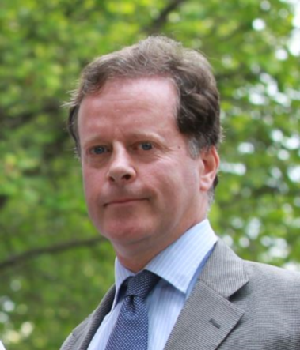
John is a professional with a strong financial education and career background. He has worked with HSBC in Eritrea, where he played a significant role in establishing bank training programs.
In 2000, John founded the Vita program in Eritrea, demonstrating his commitment to making a positive impact. In 2005, he extended his efforts to Ethiopia, assisting in the establishment of Vita's initial programs in the country. John's dedication to development work led him to return to Ireland in 2007 where he subsequently took the helm at Vita. Since 2008, John has served as CEO, a position that has allowed him to focus on creating innovative, non- traditional models of development. One such initiative is the Irish Potato Coalition, which was established in 2014. Additionally, he launched the pilot €2m Vita Green Impact Fund in 2015, furthering his mission to drive sustainable development. This pilot fund was the precursor for the new €10m Vita Green Impact Fund 2023.
Originally hailing from Dublin, John is happily married to Smret, and together they have five children. Apart from his professional endeavors, John has a passion for languages and enjoys playing the guitar.

